NSW Holiday Destinations

Produced for

yourname Travel Services

Prepared by
yourname
July, 2026

Save this document = Save As… 115 yourname.doc
Work from this document and create a brochure for your holiday company.
Where it says yourname insert you full name
We will insert TOC and an Index into your brochure.
Insert subdocument 1Alps here

Insert subdocument 2BlueMtn here

Insert subdocument 3Sydney here

Insert subdocument 4Snowy here

Insert subdocument 5Beaches here
----------------------------------------------------------------------------------------------------
On your document insert the above then delete the following and above instructions from the original MWP115 Referencing, work on documents side by side.
Insert the following documents then remove the highlighted insert here lines


Need help just ask
From the Insert menu select Index and Tables... select the

Table of Contents, select Formal with 3 levels
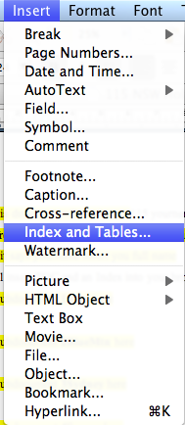
Click OK

and label TABLE OF CONTENTS

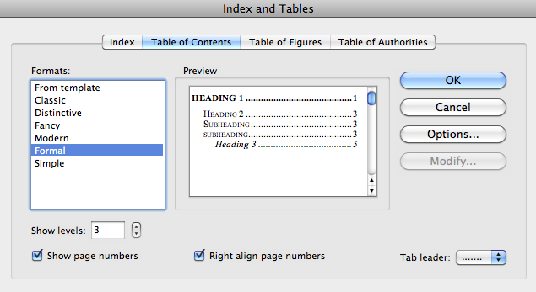

From the Insert menu select Index and Tables... select the type of index

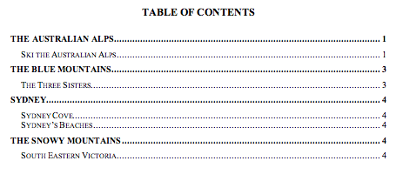
Next the index

We will make a table of contents and an index from the document go to the end of the document remove Markup if is is showing
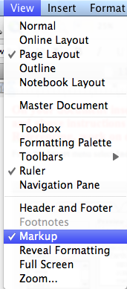
Insert the Fancy Index, indented

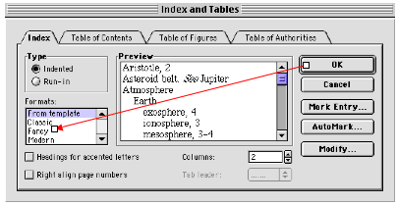

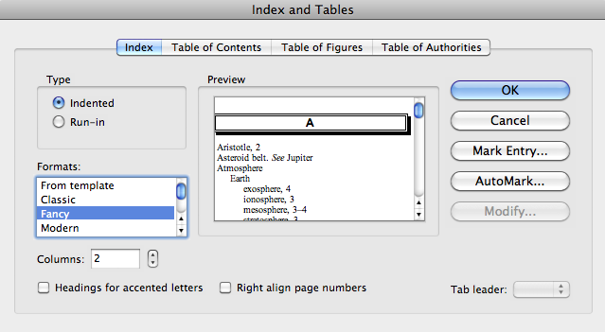

Click OK then copy the index files to the end of the document and title

Index
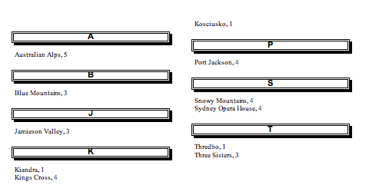

Go through the document and put eaxh section on a new page (Page Break)

Go to Page Setup and make the document layout Different First Page
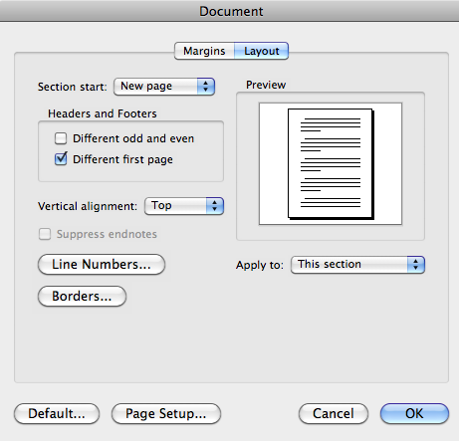
Insert headers and footers ensure that each page has a header and a footer except the first page make page numbering insert page 1 of number of pages +# etc

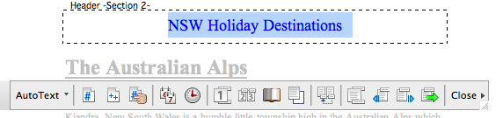

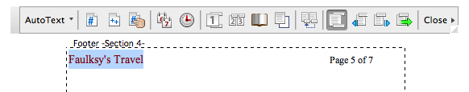

Insert appropriate pictures on each page in a text box with tight layout
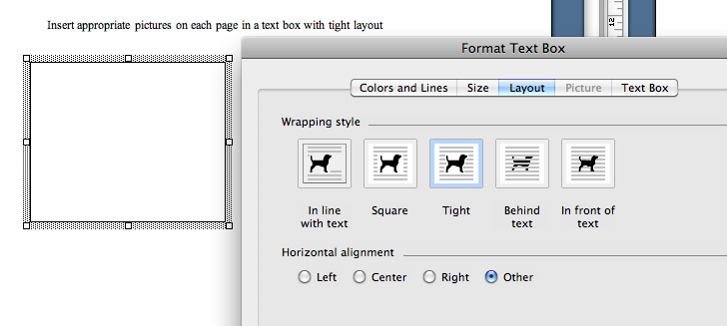

Finally change the cover page fonts add colour and a new image or logo.

Save your document

